**Module 1 - ServiceNow Platform and Development Fundamentals**

**What is ServiceNow?**

ServiceNow is a cloud-based software platform designed to streamline IT service delivery for large enterprises, empowering business users to address their own IT-related challenges. Here are some key highlights:

* **Who is ServiceNow:** Founded by Fred Luddy in 2003, the company employs over 17,000 people and counts major clients like AT&T and Microsoft among its users.
* **When did it start?**: Initially named GlideSoft, the company rebranded to ServiceNow in 2006 and successfully went public in 2012.
* **Why was it created?:**Fred Luddy founded ServiceNow to tackle inefficiencies in traditional IT departments and foster better collaboration between business and IT functions.
* **How does it work?**:ServiceNow functions as a cloud-based Application Platform as a Service (APaaS), facilitating various IT functions and automating workflows across organizations.
* **Where is it located?:** The company is headquartered in Santa Clara, California, and has a global footprint with data centers around the world.

These aspects highlight ServiceNow's evolution and its impact on enhancing IT service management and business-IT collaboration.

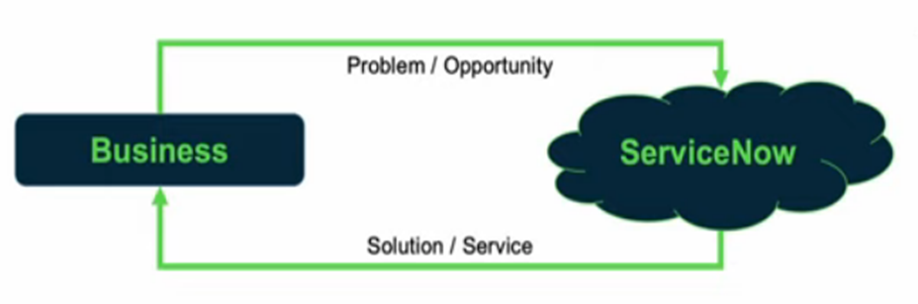

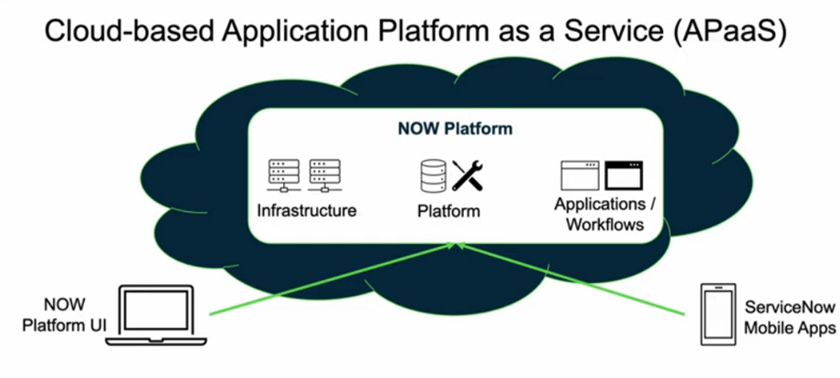

**ServiceNow Platform Overview**

* **Introduction to ServiceNow**:
  + Founded by Fred Luddy in 2004.
  + Created to empower business users to solve IT challenges using intuitive technology.
* **Platform as a Service (aPaaS)**:
  + Operates as an Application Platform as a Service (aPaaS).
  + Combines infrastructure, platform, and software services into a single platform.
  + Enables organizations to efficiently build, deploy, and manage cloud-based applications.
* **Application Categories**:
  + **IT Workflows**: Optimizes IT service management, operations, and business processes.
  + **Employee Workflows**: Enhances employee experience by automating HR services, onboarding, and other related processes.
  + **Customer Workflows**: Streamlines customer service management and improves customer engagement.
  + **Creator Workflows**: Allows users to create custom applications, driving innovation and process automation.
* **Multi-Instance Architecture**:
  + ServiceNow uses a multi-instance architecture, unlike the typical multi-tenant model.
  + Each client receives a dedicated instance for greater customization, control, and security.
  + This architecture provides flexibility in managing data and configurations.
* **User Interface Options**:
  + Offers a variety of user interfaces to meet diverse user needs.
  + Allows users to interact with applications, manage tasks, and perform administrative functions easily.
  + User-friendly design ensures accessibility for users of varying technical backgrounds.
* **Summary**:
  + The video is a valuable resource for system administration certification preparation.
  + Provides a clear understanding of ServiceNow’s core components and architecture.
  + Highlights how users can leverage the platform to optimize workflows across different business functions.

**ServiceNow User Interface Overview**

**1. User Interface Layout:**

1. **User Interface Layout:**
   * **Banner Frame:** This is the very top of the screen, including some important tools and notifications.
   * **Application Navigator:** This is the left-hand panel assisting in navigation through a number of applications and functions.
   * **Content Frame:** This is the primary workspace where users work with and view the selected applications and tasks.
2. **Key Equipment:**
   * **Global Search:** Enables users to search for content and activities across the network.
   * **Connect Chat:** Offers real-time communication and collaboration tools within the system.
   * **Contextual Help:** Provides in-app tips and guidance relevant to the current activity of the user.
   * **System Settings:** Allows users to edit the interface settings such as notifications, themes, etc.
3. **User Menu Functions:**
   * **Profile Edition:** The user can edit their personal information and preferences.
   * **User Impersonation:** This aids in troubleshooting by allowing users to act as another user.
   * **Higher Roles:** Allows access to admin-level functions and tasks as needed.
4. **Customization Options:**
   * **Global Preferences:** Modify default views and actions based on your personal preferences.
   * **Theme:** Choose and use different color schemes for the interface.
   * **Accessibility:** Configure settings to meet various accessibility needs.
   * **Notification Preferences:** Choose the method and timing of notifications.
5. **Application Navigator:**
   * **Filter Function:** Assists users in searching and arriving at specific applications.
   * **Favorites:** Users can mark applications they use frequently for convenient access and swift navigation.

The chapter concludes with a demonstration in a personal ServiceNow instance, highlighting practical use of each UI component and feature discussed. This hands-on approach helps solidify understanding of how to effectively navigate and customize the ServiceNow interface.

**ServiceNow Branding Overview**

**Branding Fundamentals:**

* **Introduction to Branding**: The video begins by explaining the importance of aligning the ServiceNow user interface with your company's corporate identity.

**Assisted Setup Wizards:**

* **Wizard Use**: Demonstrates how guided setup wizards in ServiceNow can assist with branding and other configuration tasks.

**Personalization Options:**

* **UI Elements**: Covers various customization methods such as changing logos, colors, and fonts to enhance user familiarity and comfort.

**Practical Demonstration:**

* **Hands-on Example**: Provides a live demonstration in a personal developer account, showing step-by-step how to implement branding changes.

**More Personalization Tools:**

* **Service Portal and UI Builder**: Briefly introduced as additional tools for further personalizing the user experience beyond basic branding adjustments.

**ServiceNow Lists and Filters**

In ServiceNow, lists are essential for effectively viewing and managing data from various tables, such as incidents, tasks, and problems. Users can easily access these lists through the Application Navigator or by using dot-list commands like (e.g.. task.list, incident list), which simplifies navigation and improves efficiency. The list interface includes a title bar, list header, and data rows, with built-in controls for sorting, searching, and filtering. Users have the ability to sort data by different columns, perform searches with wildcards for more precise results, and group records to uncover trends and insights.

One of the significant advantages of ServiceNow lists is their customization capabilities. Users can create and save their own views and filters, allowing them to add, remove, or reorder columns without affecting others' settings. Advanced search features and column grouping options make it easier to manage extensive datasets. Personalized lists foster better team collaboration and productivity by offering views and filters tailored to individual preferences. Efficient use of these customizable lists can significantly enhance data management and productivity within teams.

**Forms in ServiceNow**

In this lesson, we will explore forms in ServiceNow, which are interfaces used for viewing, modifying, or creating single records. We’ll cover form components such as the header bar, which displays the record type, data table, and record name, and various fields including string, Boolean, choice, and reference fields. Reference fields pull values from other tables, list fields handle multiple values, and journal fields allow notes to be visible to different users. We’ll also discuss field dependencies, where fields may dynamically appear or disappear based on other field values. Saving changes will be addressed, including options to submit, update, or save changes while keeping the form open, as well as handling unsaved changes warnings.

And also, we’ll learn about creating records from templates, which can auto-populate fields, and how to use the template bar for managing templates like a hardware incident template. Forms are organized into sections, which can be displayed as tabs or collapsible containers, and users can personalize these settings. We will also cover related lists and formatters, which provide additional record-related information and display lists of related records. Different form views are available for different user roles, and users can switch views or personalize their own. Lastly, we will discuss managing attachments, using form templates, and creating or editing form views with both the form design and layout tools.

**A Hands-on ServiceNow Tool Demo**

We will begin with a live demonstration, providing an overview of the ServiceNow interface and engaging in hands-on development to explore the platform. Next, we will cover the basics of ServiceNow instances, including how to use their URLs and the benefits of the cloud-based nature of the platform. A comprehensive walk-through of the Next Experience user interface will follow, showing you how to navigate and utilize user-specific features. We will also review the various applications available in ServiceNow, categorized into IT Workflows, Employee Workflows, Customer Workflows, and Creator Workflows. Finally, we will introduce the certification options for developers and IT professionals, highlighting how these certifications can enhance your skills and advance your career.

**Introduction to Importing Data in ServiceNow**

The Import Series in ServiceNow provides guidance on setting up and carrying out data imports with ease. It focuses on crucial aspects like data sources, import sets, transform maps, field mapping, and scheduling, all designed to help users effectively integrate data into ServiceNow.

Key concepts include the Source Data Entity, representing the data to be imported, and the Target Entity, where this data will eventually reside in ServiceNow. ServiceNow uses a Staging Table, or import set table, as a temporary storage space during the import process to manage data before it is fully integrated.

The import process consists of three main components: the Source Data, which is the original data to be imported; the Staging Table, which acts as temporary storage during the import; and the Target Data Store, which is the final destination within ServiceNow where the data is stored.

**Creating a Data Source in ServiceNow**

To set up a data source in ServiceNow, begin by configuring it with the required import parameters. You can do this by navigating to the 'sys_data_source' table via the Application Navigator or filter navigator, then selecting "New" to initiate the setup. During this process, you'll assign a name and label to the staging table, which ServiceNow will automatically create.

You’ll then choose the type of data source—either a File (such as CSV or Excel) or JDBC (for database connections). If you’re importing a file, make sure to attach it and confirm that it includes a header row to assist with field mapping. For database imports, you'll need to provide the connection details, including the server name and login credentials.

After everything is configured, click "Submit" to save your data source and ensure it appears correctly in the list. For example, if you're importing data from an Excel file, the columns like Name and Address will be used to define the fields in the staging table.

**Understanding Import Sets in ServiceNow**

This section explains the Staging Table, also known as the Import Set Table, in ServiceNow, following the creation of a data source. To test your data source, go to 'sys_data_source.list' and check the details, but remember that the staging table will only be created when you run an import. Once you start the import, the system will create the staging table and load your data into it. You can view this table by using 'u_test_import.list,' where you’ll see rows for the imported records and columns that match the headers in your source file.

If you import data again, it shows how the staging table handles records by adding the new data to what’s already there. The 'sys_import_set' table keeps track of these imports, with each import run creating a record to monitor the data. It’s important to make sure that the records in the staging table are correctly linked to the right import set so that the data imports are accurately tracked.

**ServiceNow Transform Maps & Field Maps**

This video summarizes the sometimes-convoluted process for creating transform maps and field mapping in ServiceNow. It means that the data one is trying to migrate, sitting on a temporary staging table, gets moved into a target table with least inconvenience.

Overview: This document provides a step-by-step process for developing transformation processes and configuring field mappings in the best way to facilitate data integrations into ServiceNow.

It explains about the field maps, which are the individual links between fields in the staging table and the target table.

And also, Overview of transform maps, which comprise a collection of field maps used to organize data import.

The following tutorial describes how to create a custom target table for your imported data. An accelerated and concise guide on how the Mapping Assistant tool will be used to assist the user in performing effective field mapping.

**ServiceNow Incident Management Tutorial and Task Administration**

This tutorial explains how to use ServiceNow’s Incident Management and task administration, focusing on creating, assigning, and managing tasks effectively within the platform.

**Task Definition:** In ServiceNow, a task is a record that represents work that needs to be done and is stored in the task table.

**Hierarchical Design:** Tasks like incidents, change requests, and problems are built on the task table, sharing common features while adding their own specific details.

**Task Assignment:** Tasks can be assigned to users and groups through designated fields, and assignment rules can be used to automate this process.

**Collaboration Tools:** ServiceNow includes features like user presence to help teams communicate and work together on tasks more effectively.

**Efficiency Mechanisms:** The platform uses approval processes, SLAs, and inactivity monitors to ensure tasks are completed on time and efficiently.

**ServiceNow Reporting Tutorial**

In this video tutorial, we will explore how to use ServiceNow’s reporting features. You will learn how to create, manage, and share reports effectively within the platform.

The tutorial starts by explaining how ServiceNow works with its data model and database tables to help you understand the underlying system. It highlights the ‘sys_report’ table, which is crucial as it stores all your report records.

We will then cover the various types of reports you can create, including over 23 different options such as pie charts and bar graphs. The tutorial provides step-by-step instructions on how to create these reports in ServiceNow.

Finally, we will learn how to share your reports with other users and how to set up automated email reports to keep everyone updated.

**Low Code No Code Development**

The video explores low code no code development, highlighting its ability to empower business professionals by simplifying software creation and breaking down barriers to digital transformation.

The video begins by introducing the main characters: a smart business person, an IT expert, and the Wall, which represents the old problems of traditional software development. It describes the iterative and often frustrating process that occurs between the business and IT teams in traditional development methods, highlighting the communication gaps and technical barriers.

Next, the video introduces the concept of low code and no code platforms as a solution to these challenges. It explains how these platforms help remove technical barriers, allowing users to build and modify applications without needing extensive programming knowledge.

We’ll also explore tools from companies like ServiceNow that support low code and no code development. These tools make it easier for both business and IT professionals to create applications quickly and efficiently.

The video emphasizes the benefits and limitations of low code and no code approaches, and discusses the career opportunities they present for both business and IT professionals. It highlights how these platforms can streamline development processes and open new avenues for career growth.